Why java from programming languages that writing the web Application?

* Java Applets : it is app run inside the web browser
* Security
* portability

The Bytecode

* Translating a java program into bytecode makes it much easier to run a program in a wide variety of environments because only the JVM needs to be implemented for each platform.
* The fact that a java program is executed by the JVM also helps to make it secure. Because the JVM is in control, it manages program execution.
* It is possible for the JVM to create a restricted execution environment, called the sandbox, that contains the program, preventing unrestricted access to the machine.
* Although java was designed as a in interpreted language, there is nothing about java that prevents on-the-fly compilation of bytecode into native code in order to boost performance

The Java Buzzwords

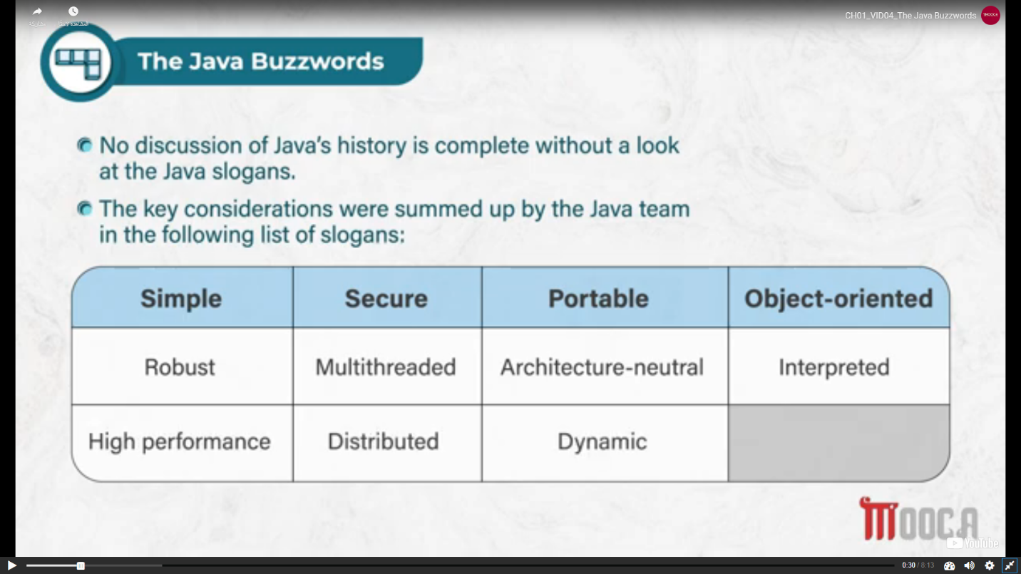

* Simple
  + If you already understand the basic concepts of Object-Oriented programming, learning java will be even easier.
  + If you are an experienced C++ programmer, moving to java will require very little effort.
* Secure
* Portability
* Object-Oriented

OOP

* Encapsulation
  + Encapsulation is the mechanism that binds together code and the data it manipulates, and keeps both safe from a outside interference and misuse.
  + In java, the basis of encapsulation is the class.
  + A class defines the structure and behavior that will be shared by a set of objects.
* Inheritance
* Polymorphism
  + It is the compiler`s job to select the specific action as it applies to each situation
  + You, the programmer, don`t need to make this selection manually, you need only remember and utilize the general interface.
  + The specific action would be determined depending on the calling object

-------------------------------------------------------------------------------------------------------------------------

* Java three Styles of Comments
* /* Comments */
* // a comment
* /** comments */ -> Comments processed by Javadoc tool
* Build In Function
* .Println(“” + var)
* .Print(“”)
* .currentTimeMillis() = .nanoTime()
* Separators
  + Semicolon ;
  + Comma ,
  + Period .
  + Colons ::
  + Elipses …
  + Ampersand @
  + Parentheses ()
  + Braces {}
  + Brackets []
* Data types
  + Primitive Types
    - Integers
      * 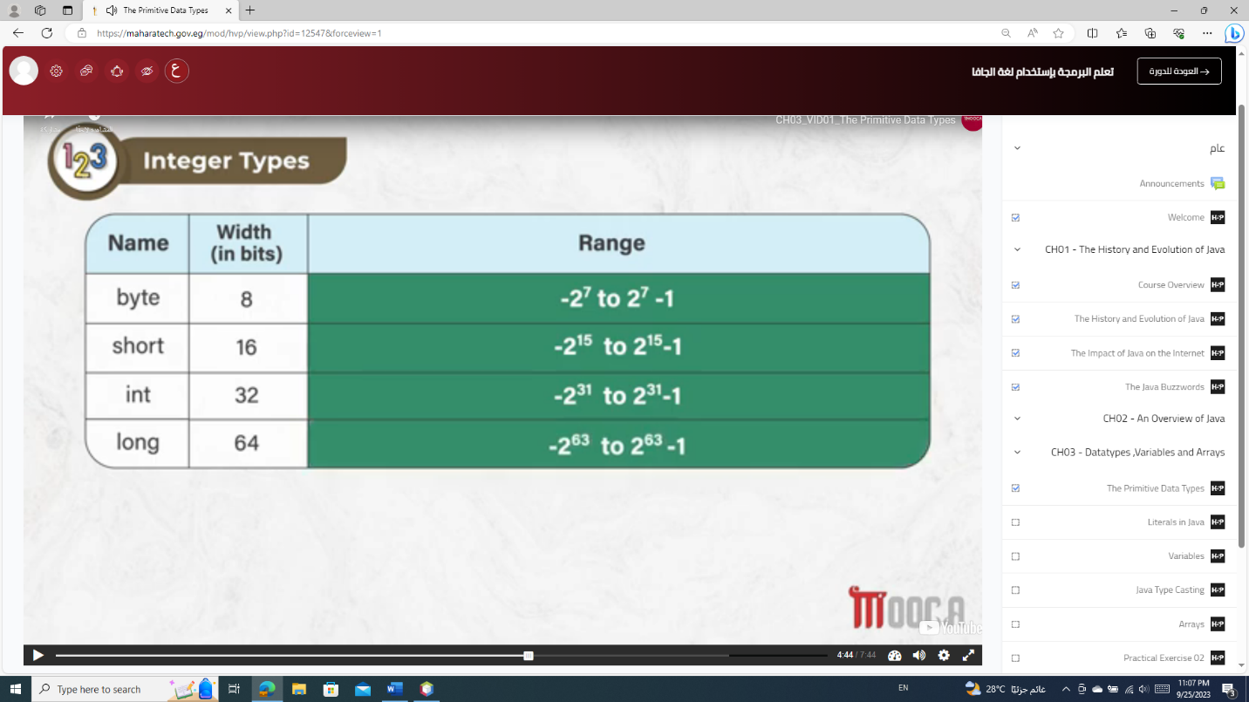
      * Byte
      * Short
      * Int
      * Long
    - Floating
      * 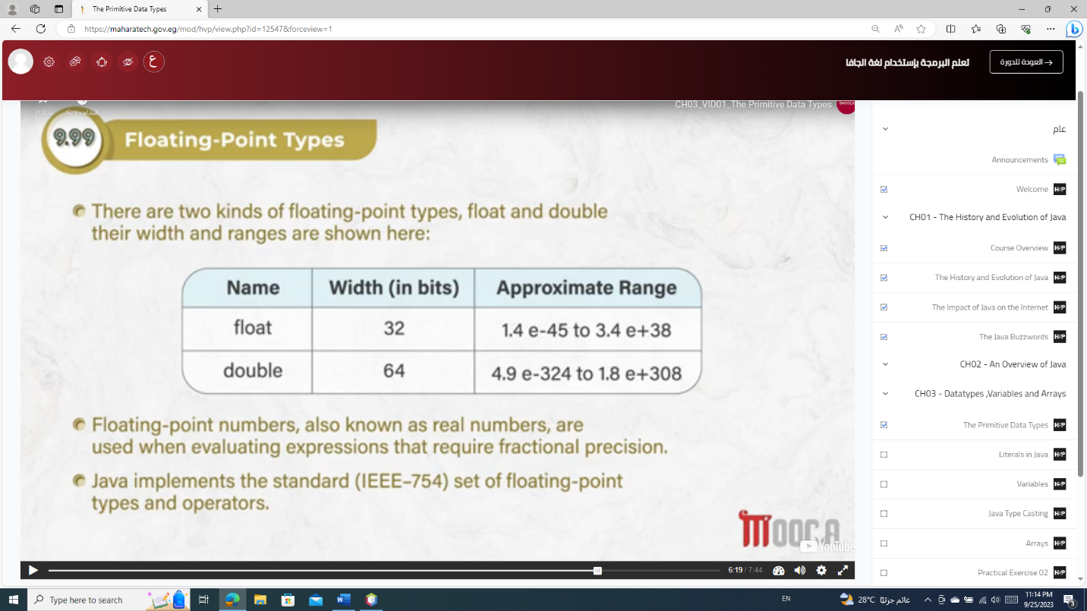
      * Float
      * Double
    - Characters
      * Char
        + It Has 2 or 1 byte

1 byte -> stored ASCII

2 byte -> stored Unicode

* + - Boolean (for logical values)
      * Bool
  + Wrapper Classes
    - Info
      * I can use objects and set values
      * It includes MIN_VALUES & MAX_VALUES for each type
      * To use class method for
        + Converting values to and from other primitive types
        + Converting to and from strings
        + Converting between number systems (decimal, octal, hexadecimal, binary)
    - Methods
      * wrapper to primitive
        + Wrapper.xxxValue()

Integer i2 = new Integer(42)

Byte b = i2.byteValue();

* + - * String to primitive
        + Wrapper.parseXxx(string)

String s1 = "12345";

System.out.println(s1);

Integer n = null;

int k = n.parseInt(s1);

System.out.println(k + 10);

* + - * String to Wrapper
  + Reference data type
    - Arrays
      * Writing method
        + Int[] Arr = new int[size]

Int[]arr = new int[]{1 , 2,3 …}

* + - * + Int [][]Arr = new int[row][col]
      * Functions
        + Arr.length
      * Build_in_function
        + Arrays.asList(arr_name) -> convert array to list
    - Class
    - Objects
      * Class_name obj = new class_name(value)
      * Class_name obj = null;
    - Interfaces
      * Default public void function_name(){implementation of function}
      * Static int function_name(){immplementation}
        + I can call this function -> interface_name.function_name_static
      * @functionalInterfaces

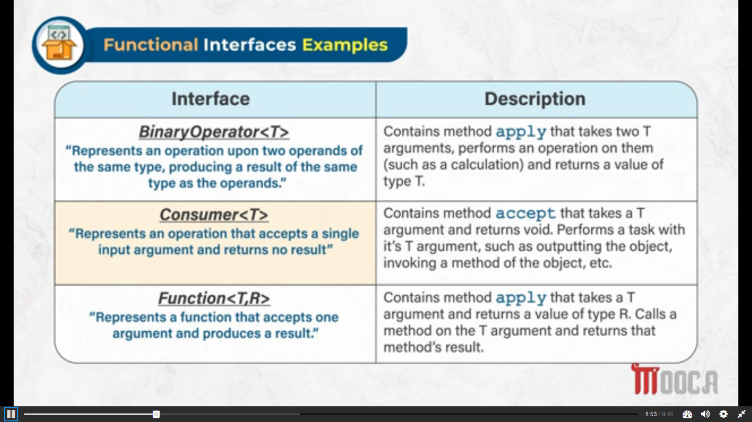

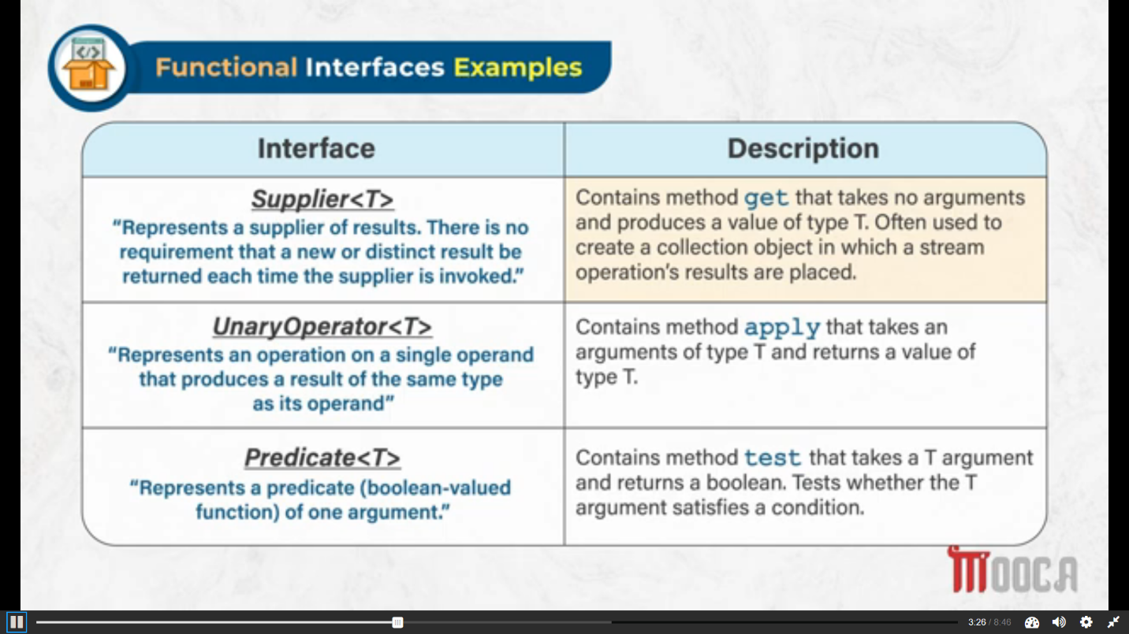

* + - * + Ex

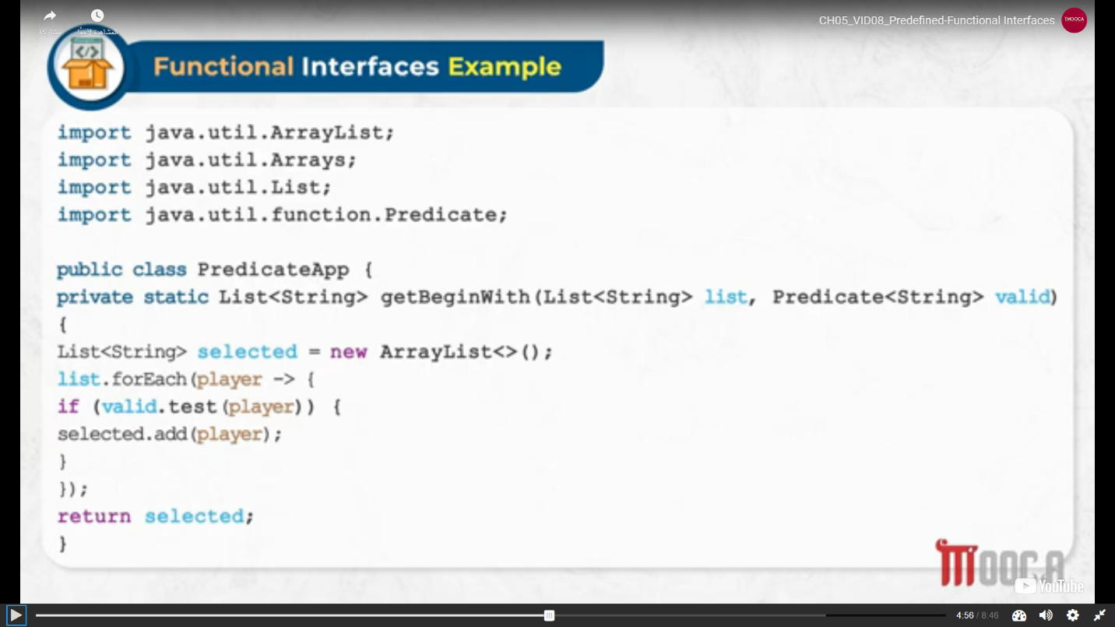

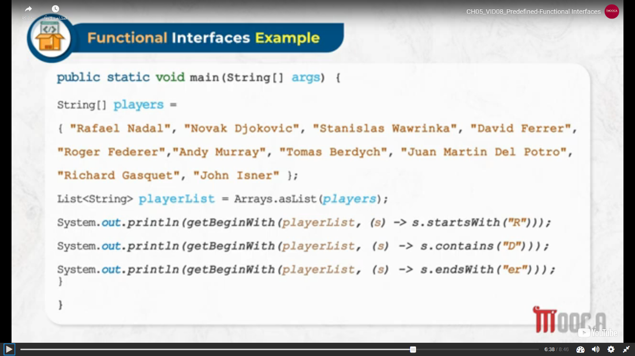

* Literals (the values that could be assigned to primitive data types or strings)
  + Integer
    - Int x = 012; int x = 10; int x = ob1010; int x = 123_456_789
    - Byte b = 0x15; byte b = 15;
    - Short s = 0X23; short s = 23;
    - Long l = 15L; long l = 15L;
  + Floating
    - Double d = 3.11232;
    - Double d = 324E-05;
  + Boolean
    - True != 1 false != 0
  + Characters
    - Char a = ‘c’
    - Char a = ‘\’’
    - Char a = ‘\u63d7’
* String
  + Info
    - In class (java.lang.String)
    - It is immutable -> constant

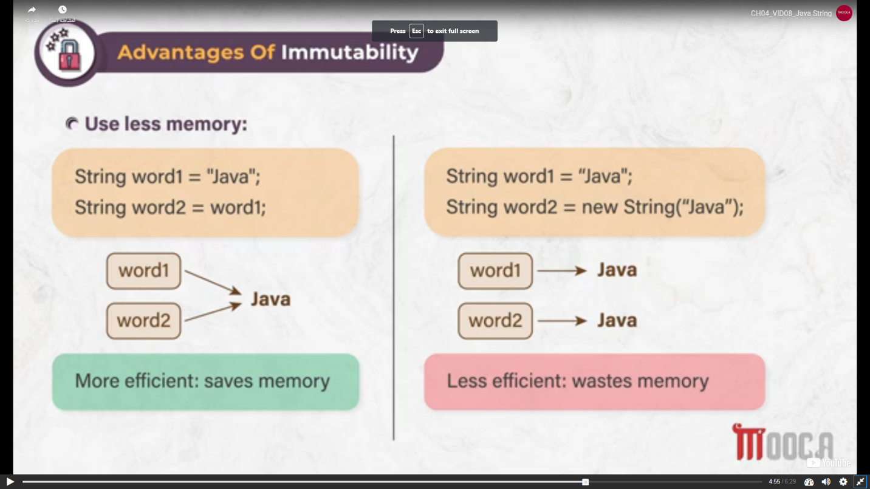

* + How to create string object
    - By string literal

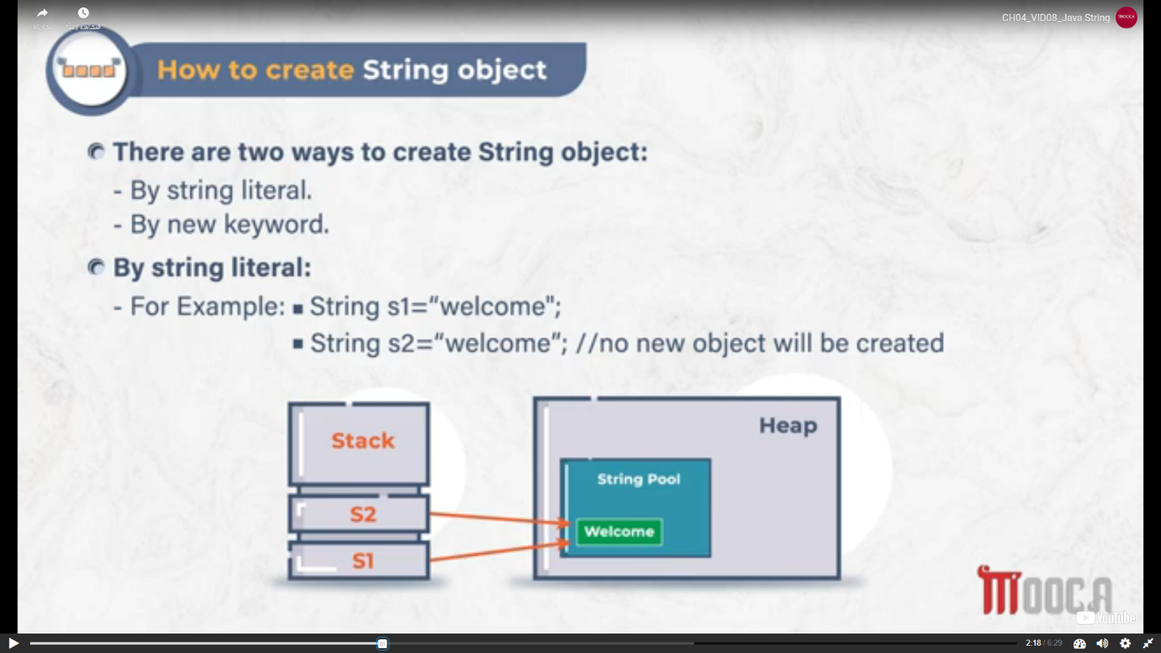

* + - By new keyword

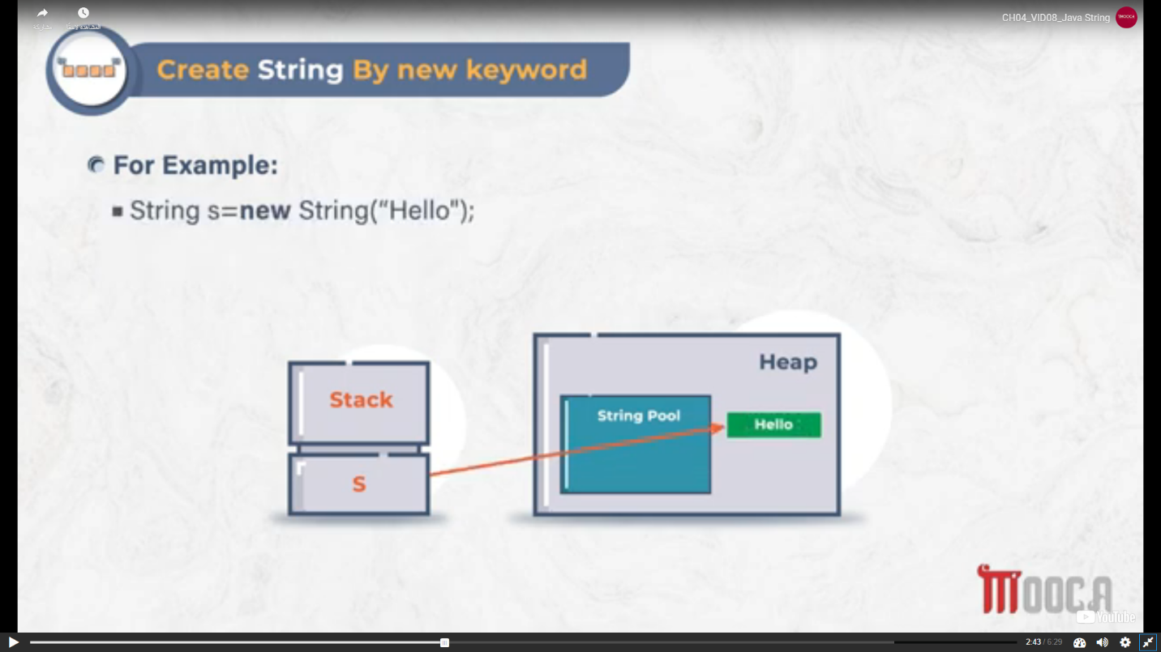

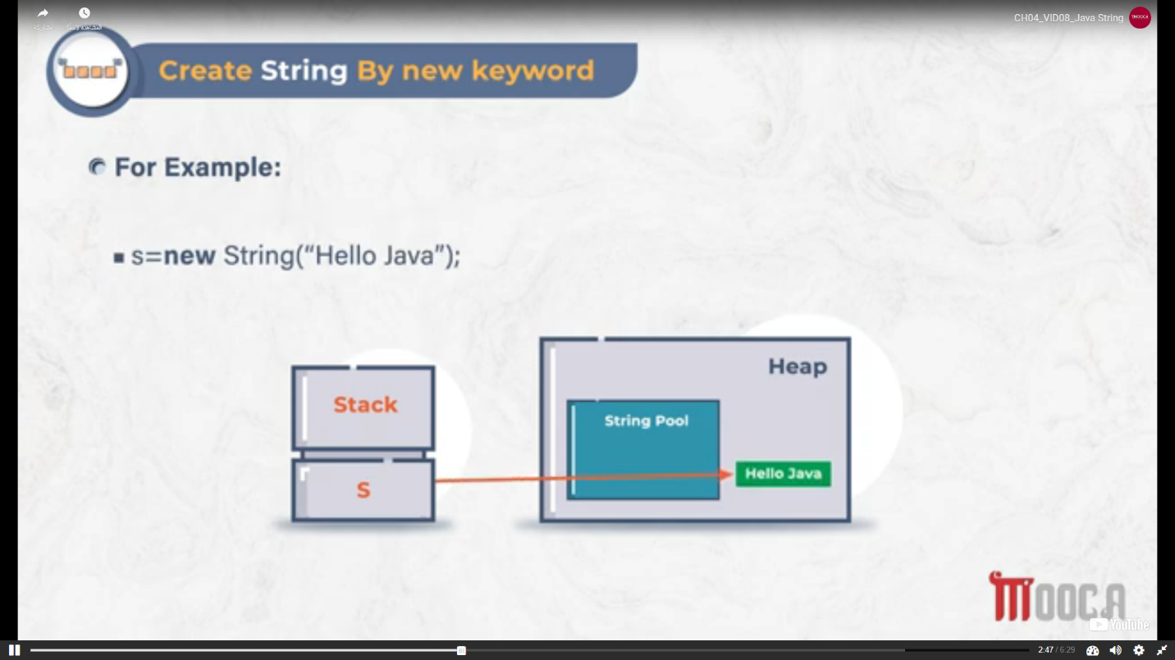

* + Methods
    - Str.substring(start,end)
    - Str.equals(“”)
    - Str.concat(“”)
    - Str.Length()
    - Str.charAt(2)
  + Classes
    - String Buffer is mutable
      * Info
        + It is synchronized and allowed us to mutate the string

If I have more than a thread that want to access on Buffer, String Buffer will allowed to one thread

* + - * + This is more useful when using in a multithreaded environment.
        + Always modified in same memory location
      * Constructors
        + Public StringBuffer()
        + Public StringBuffer(int capacity)
        + public StringBuffer(String s)
        + public StringBuffer(CharSequence cs)
      * Methods
        + Append
        + Insert
        + Delete
        + Reverse
        + Replacing Character at given index
    - String Builder is mutable
      * Info
        + It is the same as the StrinfBuffer class.
        + The StringBuilder class is not synchronized and hence in a single threaded environment, the overhead is less than using a StringBuffer.
    - String Tokenizer
      * A token is a partion of a string that is separated from another portion of that string by one or more chosen characters (called delimiters)
      * The StringTokenizer class contained in the java.util package can be used to break a string into separate tokens
* Variables
* Operators
  + Arithmetic
  + The Bitwise
    - A = 0011 1100 a << 2 (a*4)= 1111 0000 a >> 2(a/4) = 0000 1111
    - A = 1011 1100 a << 2 (a*4)= 1111 0000 a >> 2(a/4) = 1100 1111
      * A >>> 2 (unsigned right shift)= 0000 1111
      * ~a = not(a)
  + Relational
  + Boolean Logical
  + The Ternary (?)
  + Instanceof
  + The Arrow (->)
* Control Statements (Decision)
  + Selection
    - If
      * Simple if
      * If else
      * If else if Lader
      * Nested if
    - Switch Case
  + Iteration
    - Loops
      * While
      * Do while
      * for
  + Jump
    - Break
    - Continue
    - return
* Casting
  + Int a; Int b; b = (byte)a
* Keywords
  + 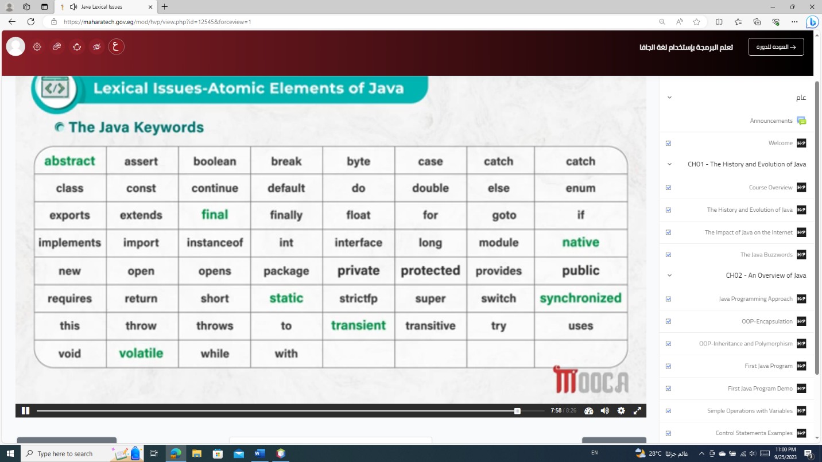
* Functions
* Packages
  + 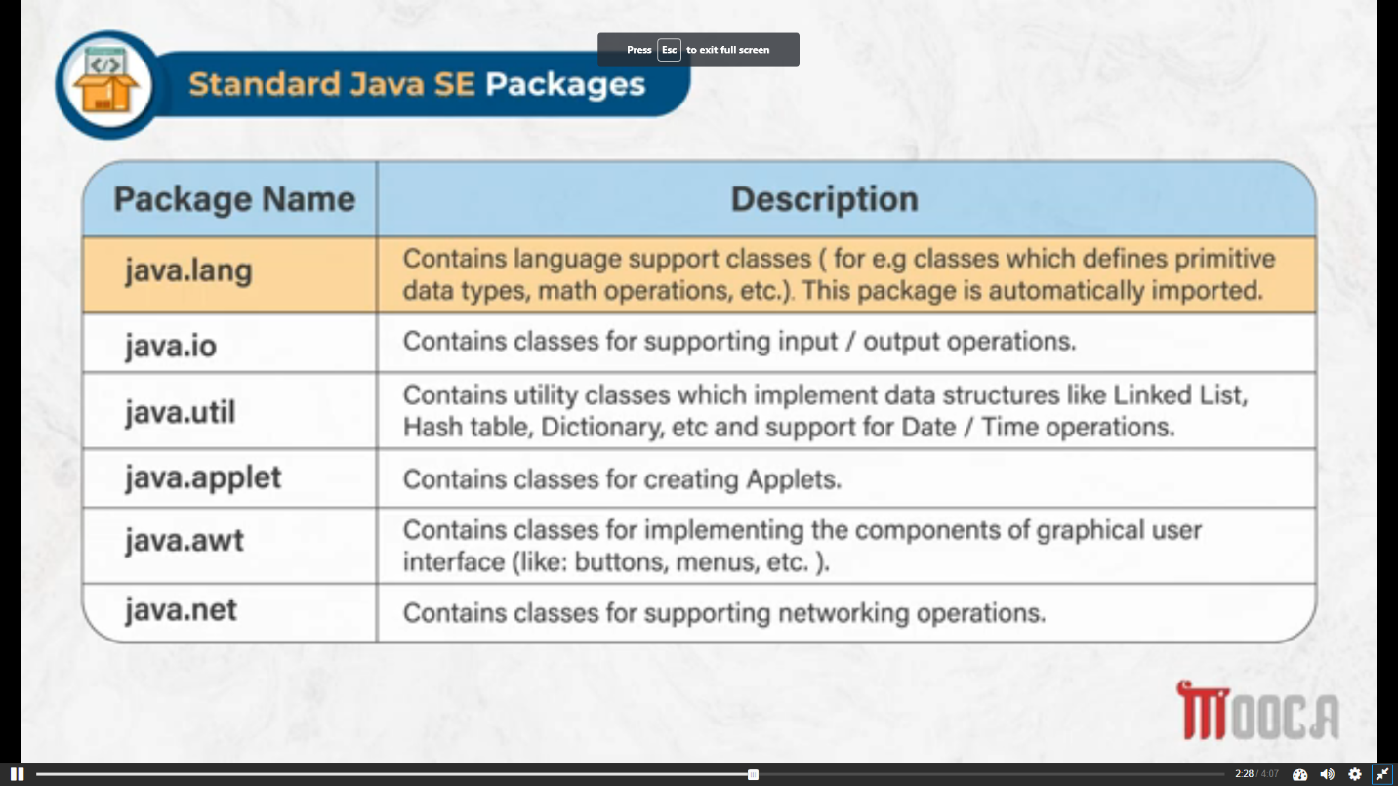
* Class
* Object
  + A a = new A();
  + Functions
    - If(Obj1 instanceof obj2)
* Notes
  + Any arithmetic operation in Floating Data Type (float or double) has a result
    - Java implements the standard (IEEE-754) set of floating-point types and operators.
  + == -> checks on reference , str.equals(“”) -> checks on value
  + It is not allowed to make casting between StringBuffer & StringBuilder & StringTokenizer & String because they don`t inheritance about them
  + Names
    - Public abstract class class_name implements interface_name{}
    - Public abstract double function_name(){}
    - Public interface interface_name{}
    - Public class class_name extends parents_name{}
    - Public double function_name(){}
    - Public class_name(){} -> constructer
    - Interface_name re; -> reference from interface
      * Re = object_name (الابجيكت بتاع كلاس بيعمل امبليمينت لل اراي)
        + Re.function_name (اسم الفانكشن الموجوده جوه الانترفيس)
        + وكده علشان اتعامل مع الفانكشن اللى فلا الانترفيس بس مش كل اللى موجود جوة الكلاس

----------------------------------------------------------------------------------------------------------------------------

Questions

* Mhara-tech
  + Binary-search
    - int num = 9;
    - int [] arr_algo = new int[]{1 , 2, 3, 4, 5, 6, 7, 8, 9, 10 };
    - int start = 0 , end = arr.length-1;
    - int middle = (end-start)/2;
    - while(end > start){
    - if(num < arr[middle]){
    - end = middle;
    - }
    - else if(num > arr[middle]){
    - start = middle;
    - }
    - else{
    - break;
    - }
    - middle = (end+start)/2;
    - }
    - if(arr[middle] == num){
    - System.out.println("Yes, Num : " + arr[middle]);
    - }
    - if(end < start){
    - System.out.println("Not found");
    - }
  + Given a sentence and a word, your task is that to count the number of occurrences of the given word in the string and print the number of occurrences of the word
    - String sentence = "I Love En Language, JAVA Language , C Language";
    - String word = "Language"; // 8
    - int count = 0;
    - for(int i=0; i<sentence.length(); i++){
    - if(sentence.charAt(i) == word.charAt(0)){
    - String search = sentence.substring(i , i + word.length());
    - System.out.println(search);
    - if(search.equals(word)){
    - count++;
    - i += word.length();
    - }
    - }
    - }
    - System.out.println(" count : "+count);